

**Report on OOP project**

*Faculty of Information Technology*

**Discipline:** Object-Oriented programming

**Project name**: University System

TEAM: “INSOMNIA”

Kovrizhnykh Grigoriy,

Kenesbek Asylmurat,

Arslan Koshimov​,

Myrzakhanov Zhanibek

Content

1. Introduction
2. General information
3. Diagrams
   1. Use-case UML diagram
   2. Class UML diagram
4. Code
   1. Package Users
   2. Package AcademicEntities
   3. Package Logs
   4. Package Researcher
   5. Package Language
   6. Package DataRepo
5. Documentation
6. TPM(Test program and methodology)
7. Work process
   1. GIT
   2. Telegram group
   3. Chat screenshots
   4. Chat link
8. Conclusion

# Introduction

That project has an idea of creating an analog of the university system. System has it`s own users and academic entities, as well as some business logic. Users can log in, make some changes, save the transaction and log out. Project has three parts: UML diagrams, code and main test class. Project was made with the help of Java, UmlTopCoder UML tool and infinite energy of every participant.

# General information

System provides a list of capabilities to any user:

* Everyone can log in, log out, send messages, create orders, logs and view news.
* Admin can add and delete users, view logs.
* TechSupport specialist can manage orders.
* Manager can create courses, publish news, create journals, approve student registrarations, add teacher to course, view info about students and teachers.
* Teacher can create lessons, put marks, view courses, create complaint on student.
* Student can view his marks, transcript, courses. He can apply for a course, subscribe to journal, get into student organization, rate teachers.
* Researcher can create research papers, projects, print papers, get citations on his papers, join to other projects.

System uses file database to save data.

Data is saved when user logouts, so we can see a transaction which will be rolled back if user closes the window.

Classes do not keep object instances inside, they keep only identifiers. This is due to the complexity of writing serialization process without an opportunity to use 3-rd party libraries like Jackson.

Project works well on Eclipse IDE(2023-09) and Java SE 17.

# Diagrams

Svg alternatives are in the final project zip.

* UML use-case diagram:

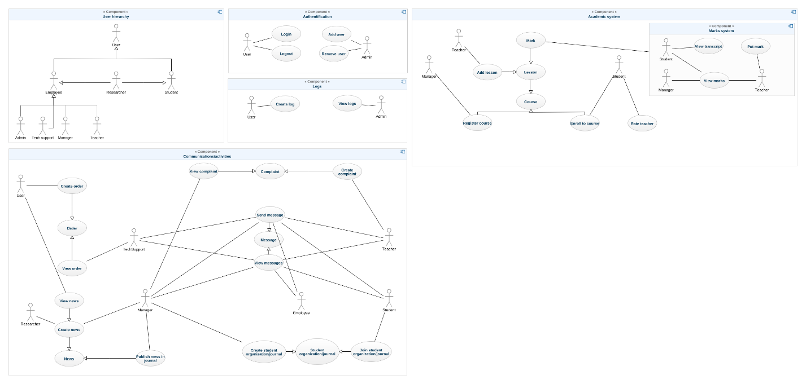

* UML class diagram

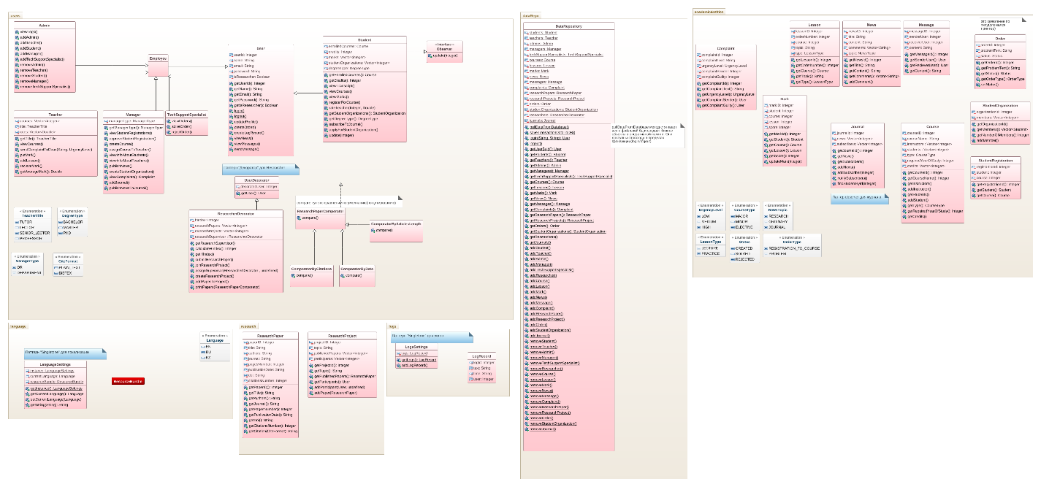

# Code

## Package Users

Package users describes the roles of the system. It shows the inheritance of user hierarchy and allows specific users to have access to specific actions.

Here will be presented some unique features of every user:

Admin

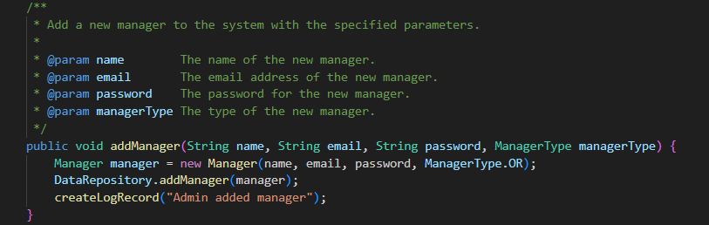

TechSupport specialist

Manager

Teacher

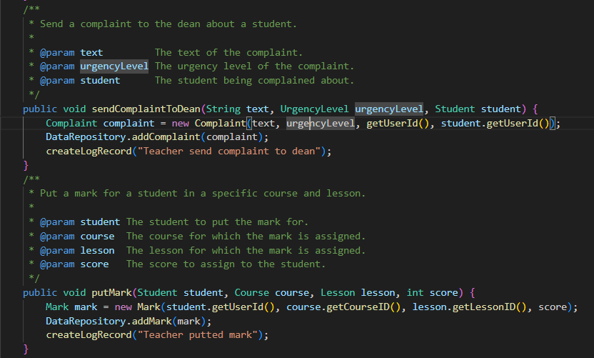

Student

Researcher

## 

## Package AcademicEntities

Here system keeps all academic entities like mark, course, message etc.  
The main entities are:

Course

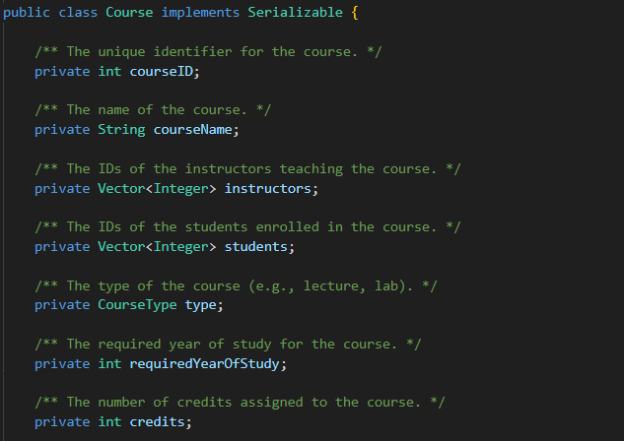

Lesson(belongs to course)

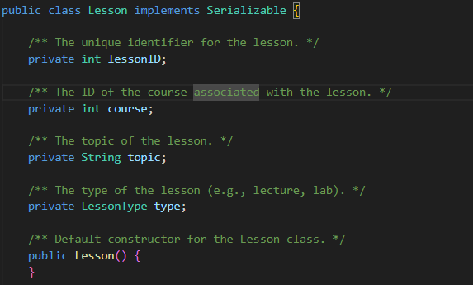

Mark(belongs to lesson and course)

Student registration

Message

Other classes are: news, complaint, journal, student organization, order, complaint.

## 

## Package Logs

Logs are saved on each user action in a special file.

Admin can view logs.

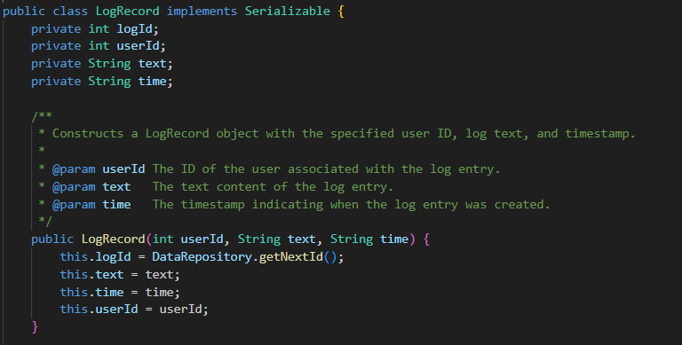

## 

## Package Researcher

Student, teacher and ordinary employee can be a researcher in our system.

Researcher can create research papers, projects, print papers, get citations on his papers, join to other projects.

Research Paper has special fields and can be citated in different formats(PLAIN_TEXT, BIBTEX)

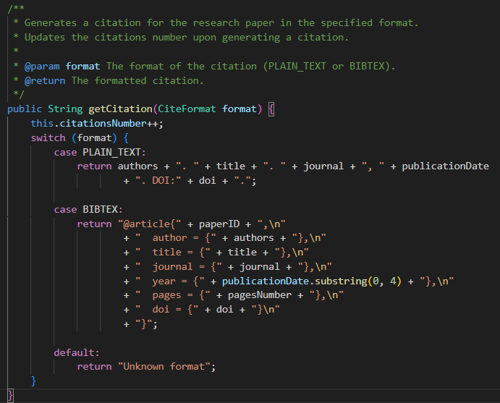

Researcher can add his papers to projects

## 

## Package Language

System can support multi-language support with the help of LogsSettings class.

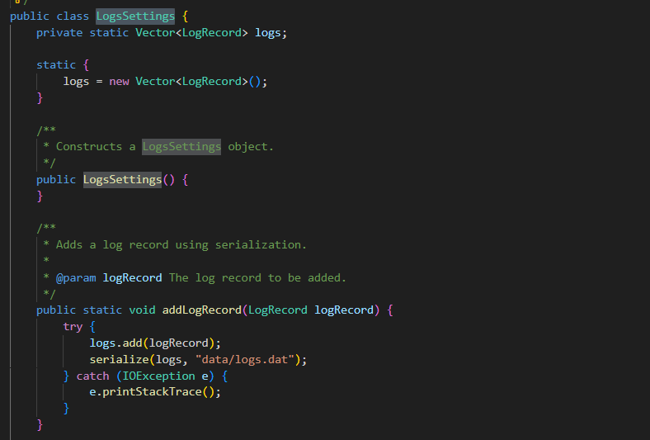

Log keep info about user, time and note

## 

## Package DataRepo

Class DataRepository keeps info about all object instances and can share it with any class.

It provides methods for data serialization and deserialization, as well as for pulling and saving data to and from the persistent storage.

Class includes vectors for different types of entities, such as employees, students, teachers, etc., and methods for accessing and modifying them.

It also manages the user login, logout, and retrieval based on user ID.

# Documentation

Documentation is created for every class and method and available in root doc folder.

# Test program and methodology

To test program we can perform operations in such order:

Admin:

* Log in as (Admin1, Admin1)
* Create Manager
* Create Teacher
* Create Student
* Log out

Manager:

* Log in
* Create course
* Assign teacher to course
* Log out

Student:

* Log in
* Register for a course
* Log out

Manager:

* Log in
* Approve student registration
* Log out

Teacher:

* Log in
* Create lesson
* Put mark to student
* Log out

Student:

* Log in
* View marks
* View Courses

Any researcher(Student or teacher if we made them researchers):

* Log in
* Create research paper
* Print papers(comparator by citations by default)
* Create research project
* Add paper to project
* Log out

# Work process

Our git link(opened on the 26th of December): <https://github.com/Heigen007/KBTU_OOP_PROJECT>

Git commit history screenshot:  
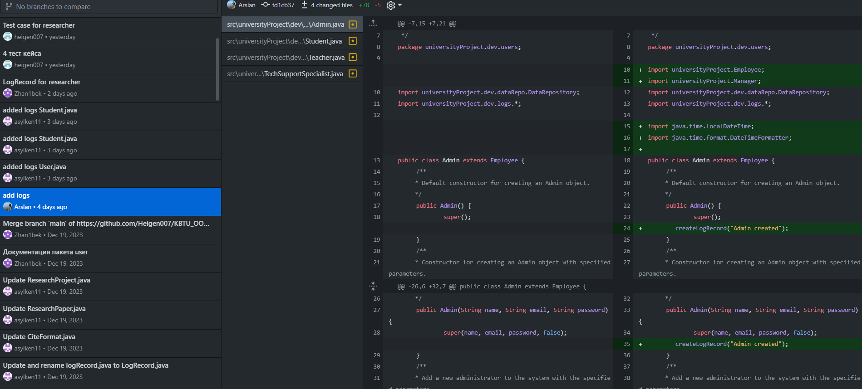

Out telegram group link: <https://t.me/KBTUOopProjectInsomniaTeam>

We used telegram chat to cooperate and discuss questions.

Screenshots:

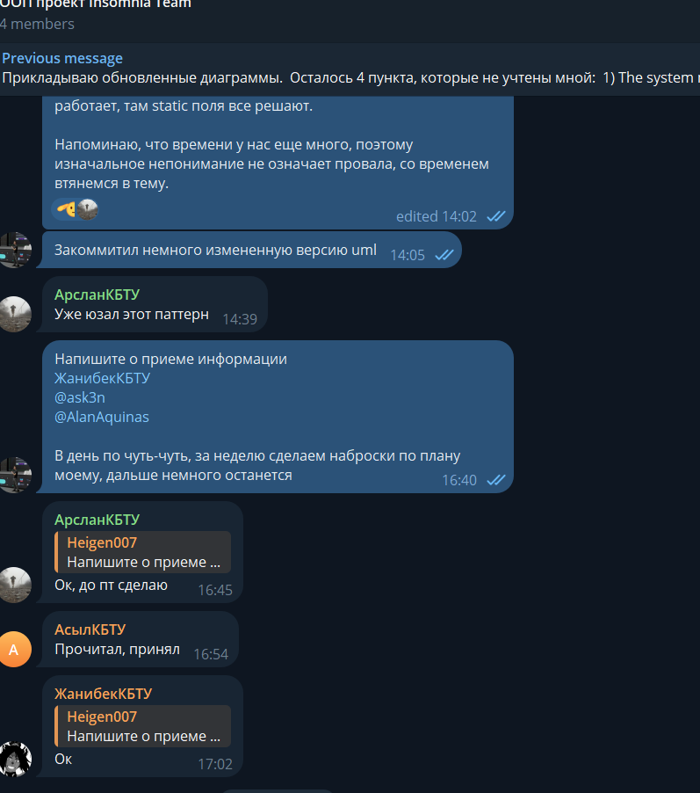

# Conclusion

Project was not given to upgrade our OOP knowledge only. It had the sacred meaning – knowledge how to work in teams. Everyone made their own conclusion based on the end of the project.

Especially for me(Grigoriy), project gave an opportunity to test one philosophical approach to team management and I have tested it.  
Thanks to Shamoi Pakita for giving such opportunity, it was a good experience for everyone.